**EV Market**

**Feynn Labs Services**

**Project 2**

**Team**

**Paresh Patil**

**Kalpataru Dhakate**

**Problem Statement:**

* To analyse the Electric Vehicle market in India using Segmentation analysis and come up with a feasible strategy to enter the market, targeting the segments most likely to use Electric vehicles.
* To decide which vehicle/customer space it will be develop its EVs.

**Introduction:**

The global electric vehicle (EV) market is developing at a rapid pace. According to EV volumes, overall electric vehicle reached a global share of 8.3% (including battery electric vehicles [BEVs] and Plug- in hybrid electric vehicles [PHEVs]) in 2021 from 4.2% in 2020 with 6.75 million vehicles on the road.

This is an increase of 108% as of 2020. EVs are gaining attention across the globe as they help reduce emissions and depletion of natural resources. The Indian EV market is also evolving fast as close to 0.32 million vehicles were sold in 2021, up 168% YoY. Ongoing electric vehicle adoption in India is based on the Paris agreement to reduce carbon emissions, to improve the air quality in urban areas and reduce oil imports.

**PROBLEM BREAKDOWN**

**Fermi Estimation**

First, we take approximate values and logics to understand problem and breakdown problems.

Start from India population (139 crore) and there are (28) states and (8) UTs in India coming back to India vehicle. The number of registered vehicles across India was around **295 million** in fiscal year 2019. Vehicle registrations grew at a compound annual growth rate of over ten percent between fiscal years 2007 and 2019. The number of registered “Transport” vehicles, both goods and passengers, as on 31st March 2017 were **22.539 million.**

Then we have to take state wise sell of vehicle and which company sell most cars and generate more revenue including price range and safety and customer satisfaction.

Then we have found which company is on top in petrol, diesel and EVs market is there is any same company which is on top in both sector if yes then why?

Then we go to EVs KM range, durability, safety, customer satisfaction, charging time, battery policy etc.

Charging stations range between both stations (kms).

**First Principal Analysis**

We Analysis problem in approximate way from above then We start this First principal analysis from what is the problem and what is the need of customer and most important WHY?

Why is EVs is important than petrol, diesel.

Is this is suitable for all

Is this future or long-term stability to use EVs or only for short term use

WHY?

WHY?

WHY?

Transport industry of India and emission challenges

With one of the lowest motorization rates in the world (22 cars per 1,000 people2), India is among the fastest growing countries in transportation sector. From 2011 to 2020, India’s domestic vehicle sale (2W, 3W, Passenger Vehicle, Commercial Vehicle) has grown at ~4% CAGR. With rising income and rapid urbanization, the Indian mobility market is expected to expand rapidly.

Transportation, however, has contributed significantly in India’s overall GHG emission. During year 2016, transport sector contributed to 270.6 MT CO2e of GHG emission 3, third highest, only after power industry and industrial combustion. Within transportation, road transport has been the highest contributor to the GHG emission. With the rising transport industry, India is also facing intense emission challenges.

India therefore has a great opportunity to leapfrog towards decarbonizing the transport system to meet its NDC commitments and to overcome environmental issues which would likely to become more severe, if remain unaddressed, as India has huge prospects for growth.

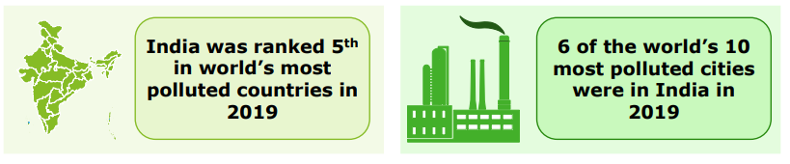

As India is experiencing acute challenges in controlling its carbon emissions, the country expects the emission level to grow even further as its transport industry is expanding. To tackle the emission from the transport industry, India is moving towards “zero or low carbon emission” transportation model by promoting the use of alternative fuel vehicles and Electric Vehicles (EVs).

**DATA COLLECTION**

**Road transport industry in India**

India has the second-largest road network in the world, spanning a total length of 5.89 million Kms6 Road transport contributes towards 64.5% of the country’s overall goods movement and caters to 90% of India’s total passenger traffic. Road transport has been a preferred mode of transport for any passengers and goods movement vis-à-vis other modes of transport like air, water and rail transport. Road transport generated the highest Gross Value Addition (INR 5.31 Tn) amongst other transportation segments in FY19. It contributed ~78% towards the overall GVA added by transportation sector during the year.

**India’s automobile sector**

India is the fifth largest automobiles market in the world, with 3.82 million units sold in 2019. Following schematic highlights, the categorization of automobiles in India.

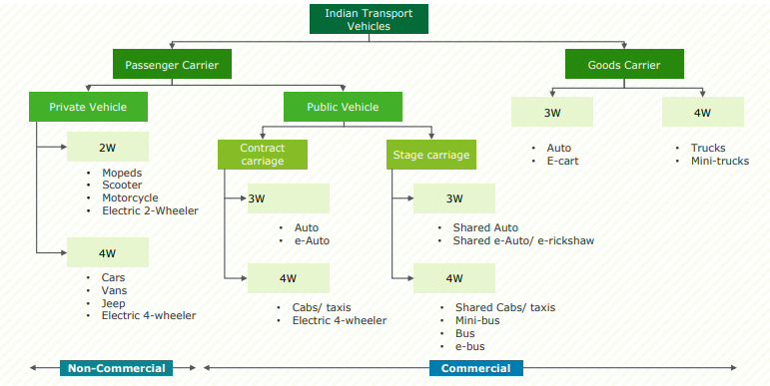

It is expected that with growth in urbanization coupled with likely impact of increasing per capita income, the slump in vehicle sales, as observed during FY20, will not continue in the future. However, the concerns around environmental impact of conventional fuel and import dependency have pushed India to re-think its automobile/ transport sector expansion strategy.

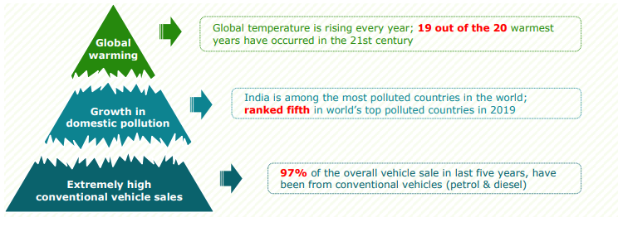

**Fuel import status of India**

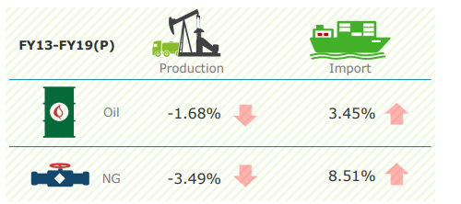

Decline in production of crude oil and natural gas during FY13 to FY19 has further contributed towards country’s import dependency

**India’s options for clean mobility**

**Electric vehicles**

Among available clean/ low carbon mobility technologies, electric vehicles and CNG vehicles are most preferred in India. Availability of fiscal incentives for electric vehicles and low prices of CNG compared to petrol and diesel could explain such preference for these technologies.

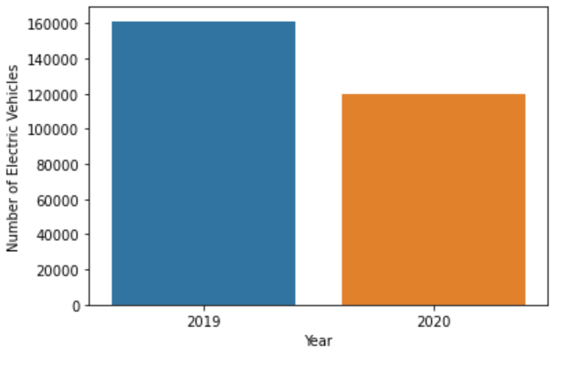

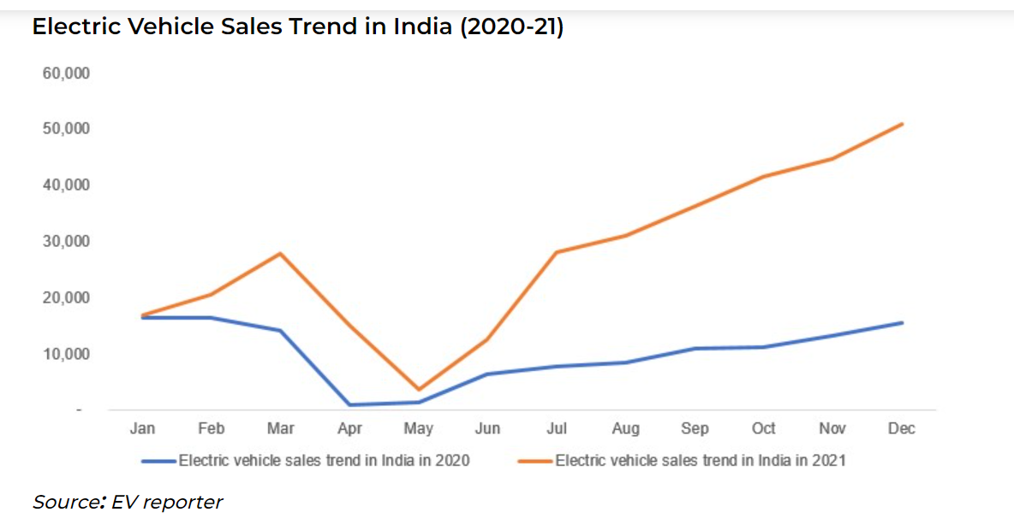

EVs have emerged out as a promising alternative that could help in mitigating the adverse environmental impacts caused by conventional vehicles.

**Data Sources:**

<https://www.kaggle.com/datasets/nehalbirla/vehicle-dataset-from-cardekho>

[All India level Composition of Vehicle Population during 2015-2016 |Open Government Data (OGD) Platform India](https://data.gov.in/resource/all-india-level-composition-vehicle-population-during-2015-2016)

<https://data.gov.in/>

<https://www.kaggle.com/datasets/kkhandekar/electric-vehicles-india>

<https://ev-database.org/>

**DATA PREPROCESSING**

* Importing Libraries like request and beautiful soup to scrape the data from site.
* Importing Libraries like Pandas, NumPy, seaborne to manipulate and analyzed the data.
* Get unique features, get dummies variables, remove null values

**Exploratory Data Analysis**

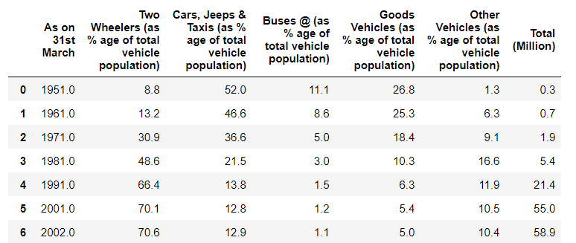

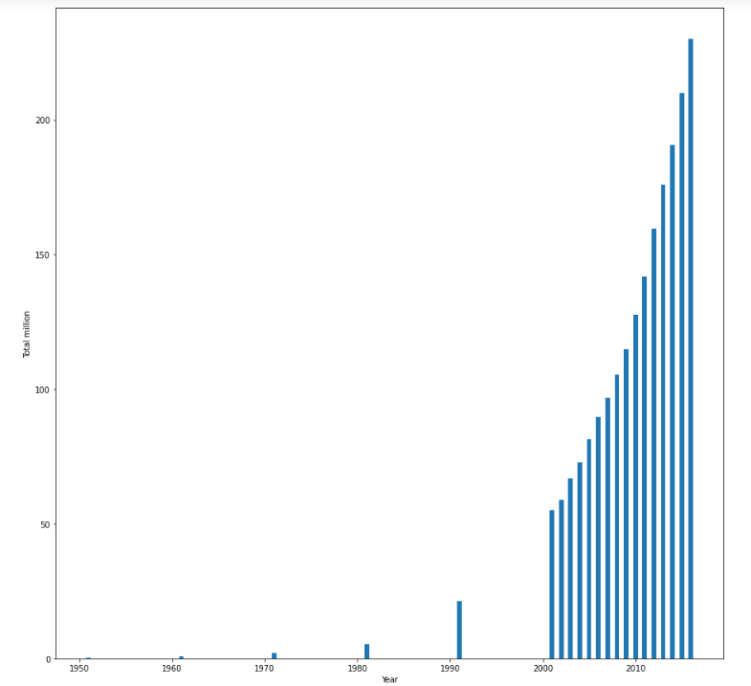

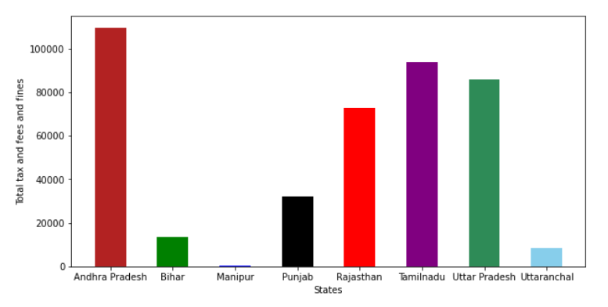

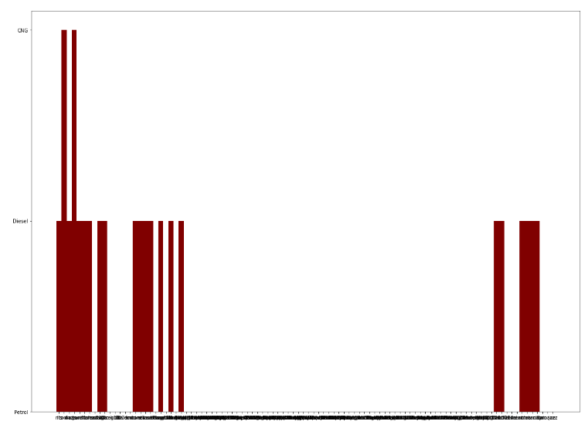

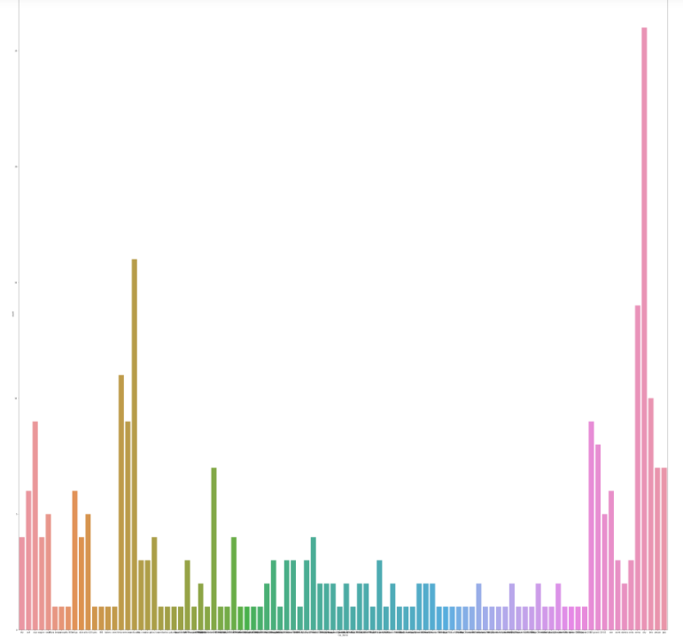

**Electric Vehicle in UK, Germany, Netherlands**

Why are we using Electric vehicle data of UK, Germany, Netherlands?

As we have to analyze the Electric Vehicle market in India using Segmentation analysis and come up with a feasible strategy to enter the market, targeting the segments most likely to use Electric vehicles.

Hence, we need to analyze data of electric vehicle of UK, Germany, Netherlands so that we can launch the vehicle which is most commonly used there in terms of battery, acceleration, top speed, range, efficiency, fast charge speed.

**Data Sources:**

The data used here for analysis is scraped from the following site to extract the data.

Site used for scraping is: <https://ev-database.org/>

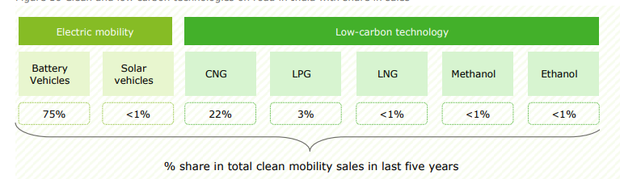

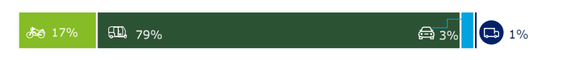

79% of the EV addition is from three-wheeler segment, followed by two wheelers (17%); the four-wheeler segment contributes only 3% towards the overall EVs on the road

**Extracted Data Look Like:**

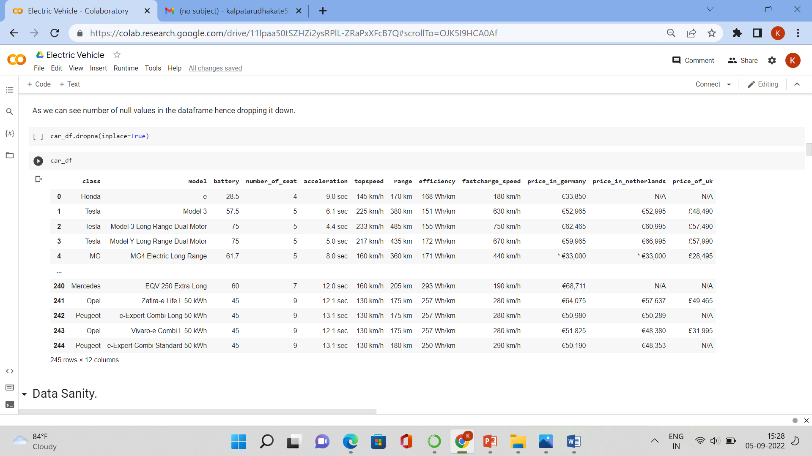



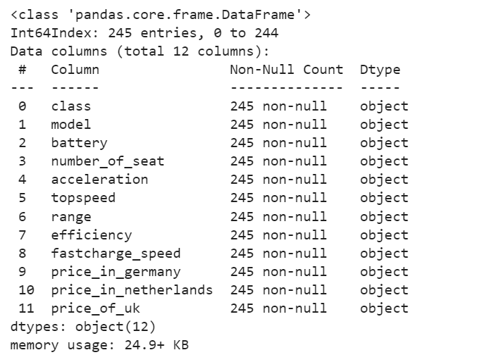

We can see that all the variable has dtype 'Object'. Hence to get insights about the data we need to convert certain variable dtype into 'int64'.

**Analysing Market Segments**

**Geographical Segment:**

Correlation of Variables:

1. We can see that Variable name Battery is highly correlated with Fast charge speed, top speed and
2. range.
3. Variable Name Efficiency is highly correlated with Number of seats.
4. Also, we can see that Fast charge speed is highly correlated to Top speed and range.

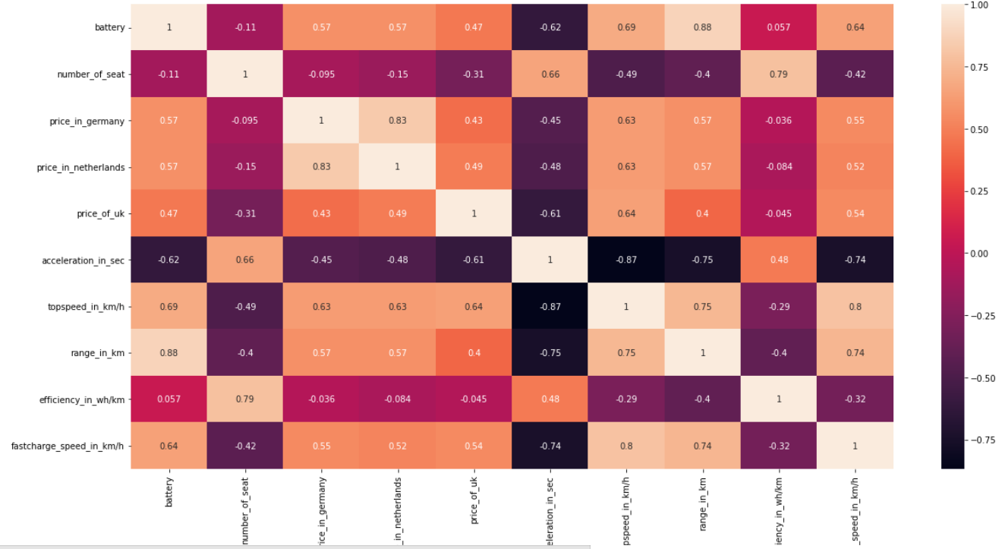

Efficiency Ranking of Electric Cars.

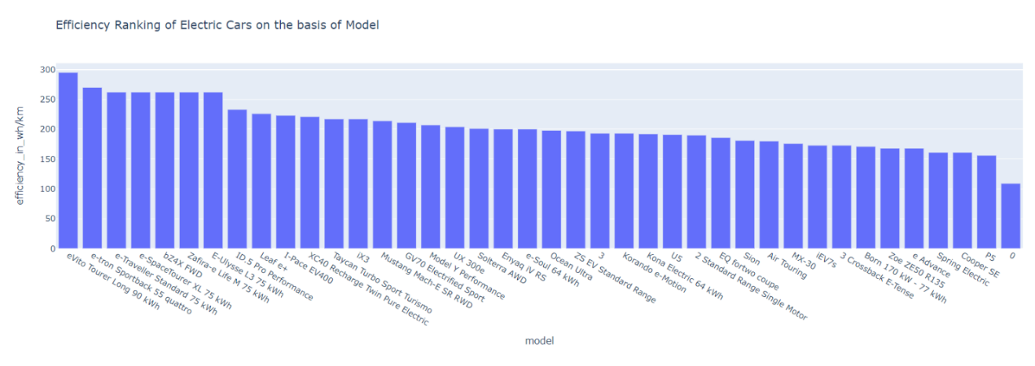

We can see that in Top 5 model in Efficiency ranking are:

1. eVito Tourer Extra-Long 90 kWh.
2. e-tron Sportback 55 quattro.
3. e-Traveller Standard 75 kWh.
4. e-SpaceTourer XL 75 kWh.
5. bZ4X FWD.

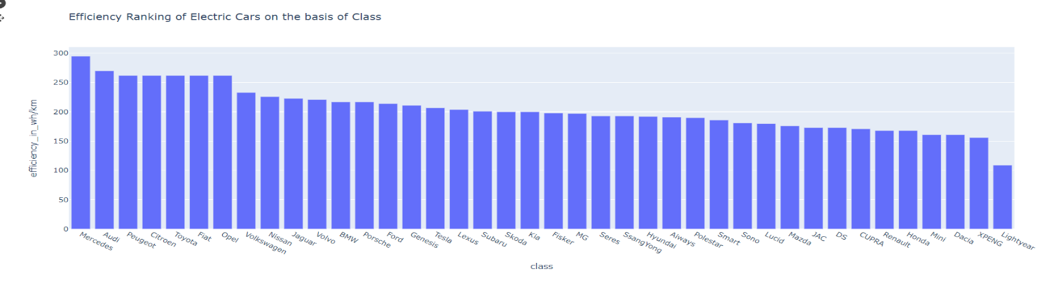

We can see that in Top 5 class in Efficiency ranking are :

1. Mercedes.
2. Audi.
3. Peugeot.
4. Citroen.
5. Toyota.

Battery Ranking of Electric Cars.

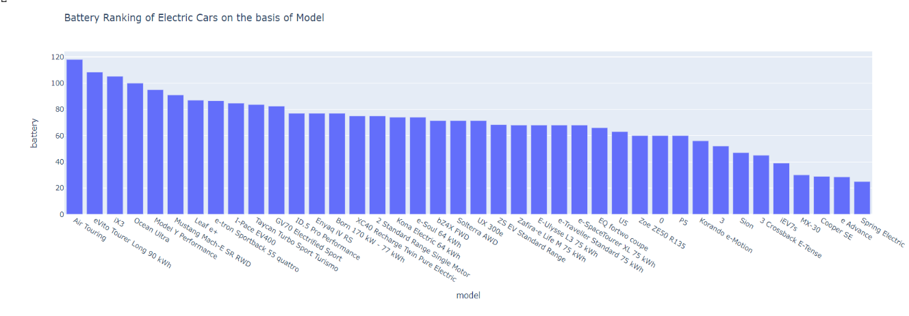

We can see that in Top 5 Model in Battery ranking are :

1. Air Touring.
2. evito Tourer Long 90 kWh.
3. iX3.
4. Ocean Ultra.
5. Model Y Performance.

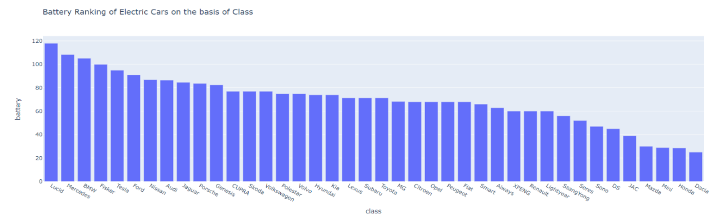

We can see that in Top 5 Model in Battery ranking are :

1. Lucid.
2. Mercedes.
3. BMW.
4. Fisker.
5. Tesla.

Range Ranking of Electric Cars.

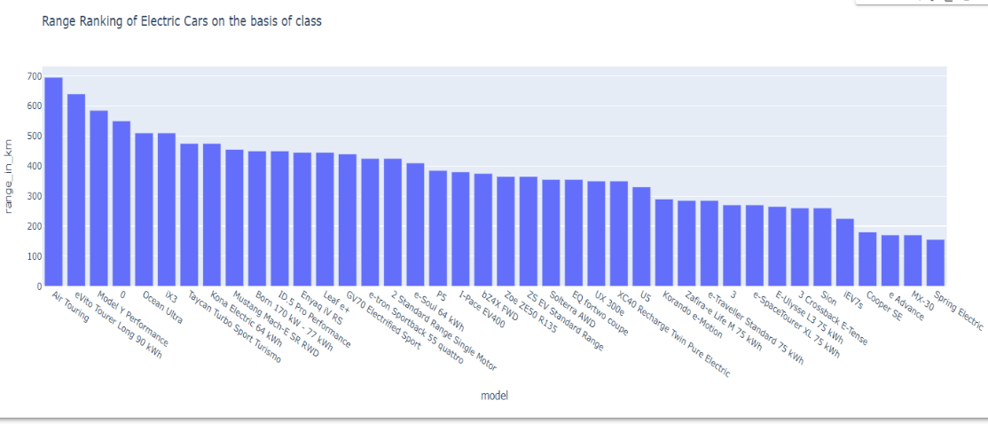

We can see that in Top 5 Model in Range ranking are :

1. Air Touring.

2. evito Tourer Long 90 kWh.

3. Model Y Performance.

5. Ocean Ultra.

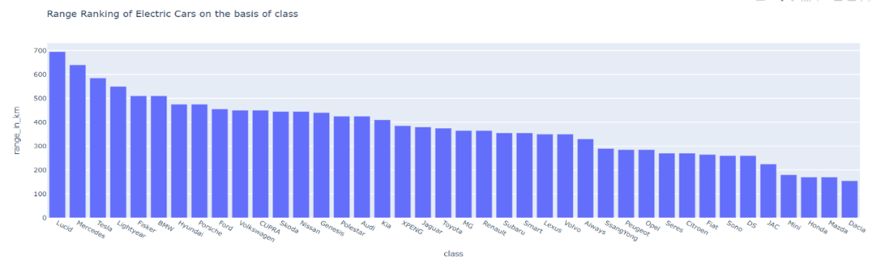

We can see that in Top 5 class in Range ranking are :

1. Lucid.

2. Mercedes.

3. Tesla.

4. Lightyear.

5. Fisker.

Top Speed Ranking of Electric Cars

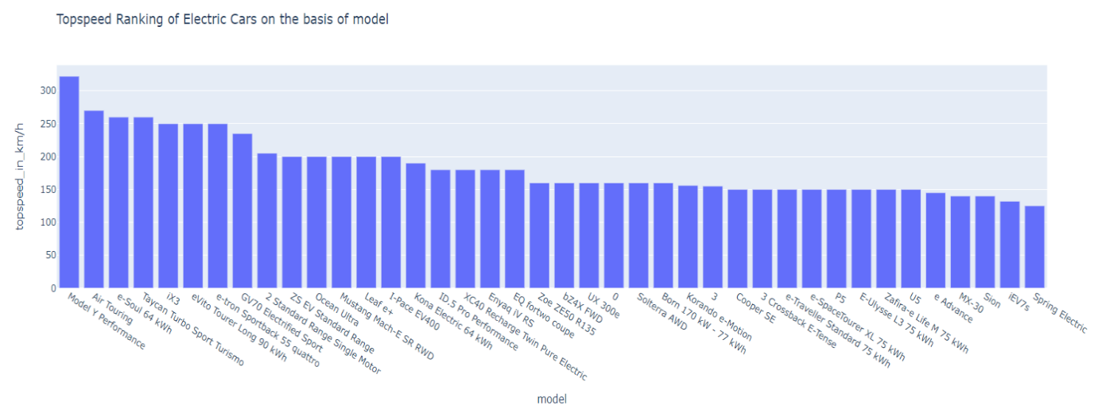

We can see that in Top 5 model in Topspeed ranking are :

1. Model Y Performance.

2. Air Touring.

3. e-soul 64 kWh.

4. Taycan Turbo Sport Turismo.

5. iX3

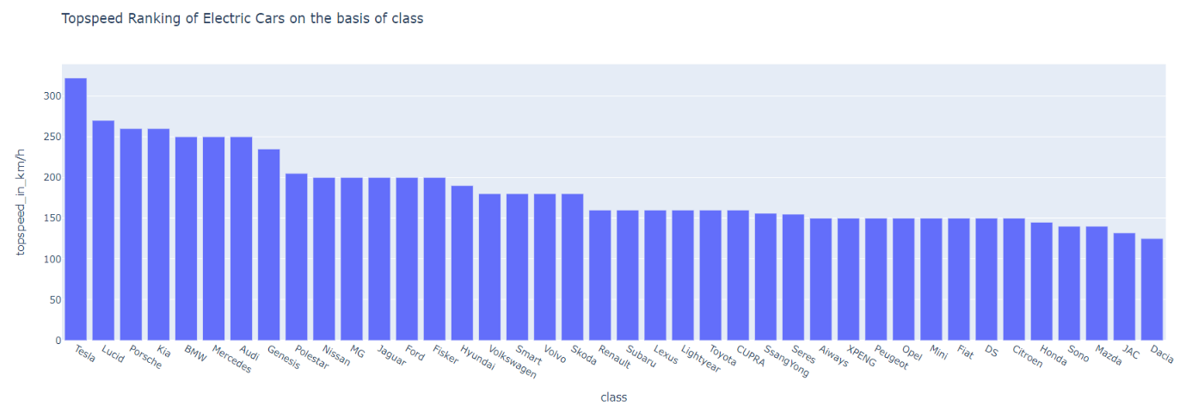

We can see that in Top 5 class in Battery ranking are :

1. Tesla.

2. Lucid.

3. Porsche.

4. Kia.

5. BMW.

Acceleration Ranking of Electric Cars

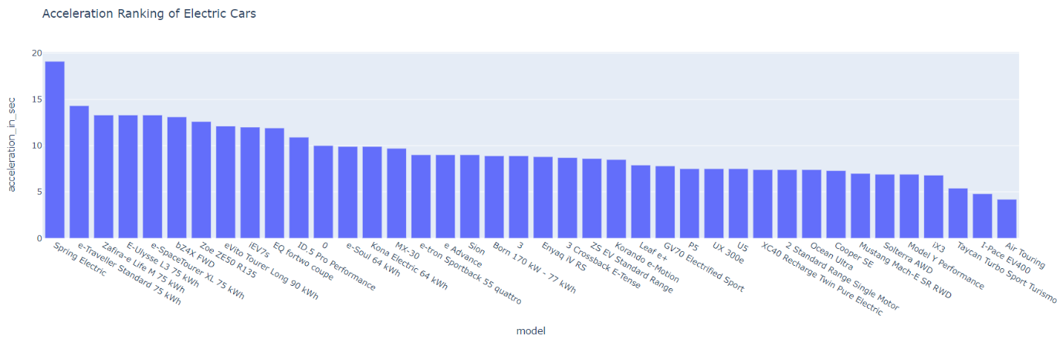

We can see that in Top 5 model in Acceleration ranking are :

1. Spring Electric.

2. e-Traveller Standard 75 kWh.

3. Zafira-e Life M 75 kWh.

4. E-Ulysses L3 75 kWh.

5. e-Space Tourer XL 75 kWh.

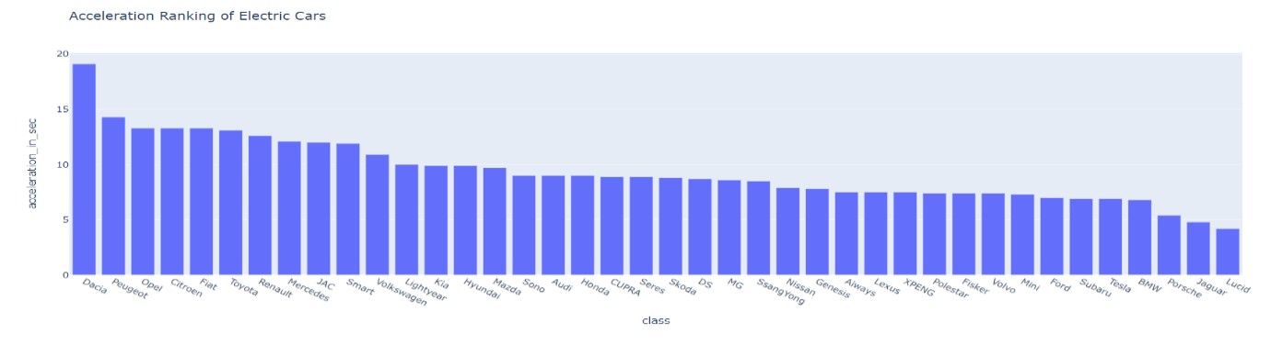

We can see that in Top 5 class in Acceleration ranking are :

1. Dacia.

2. Peugeot.

3. Opel.

4. Citroen.

5. Fiat.

Fast charge Speed Ranking of Electric Cars

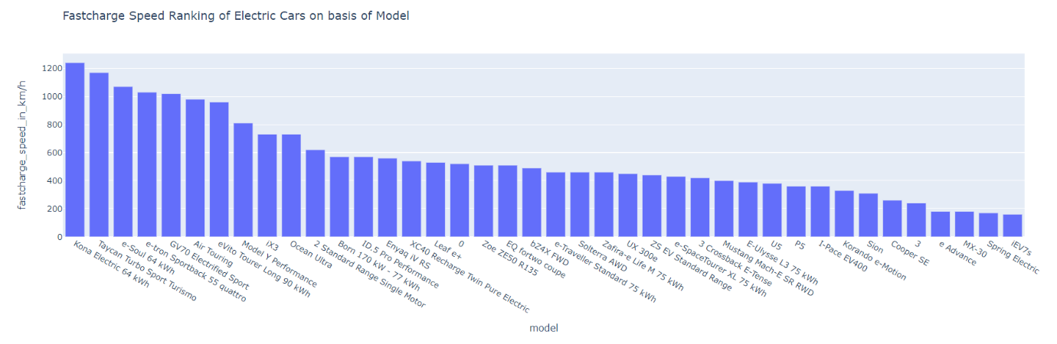

We can see that in Top 5 class in Acceleration ranking are :

1. Kona Electric 64 kWh.

2. Taycan Turbo Sport Turismo.

3. e-soul 64 kWh.

4. e-tron Sportback 55 quattro.

5. GV70 Electrified Sport.

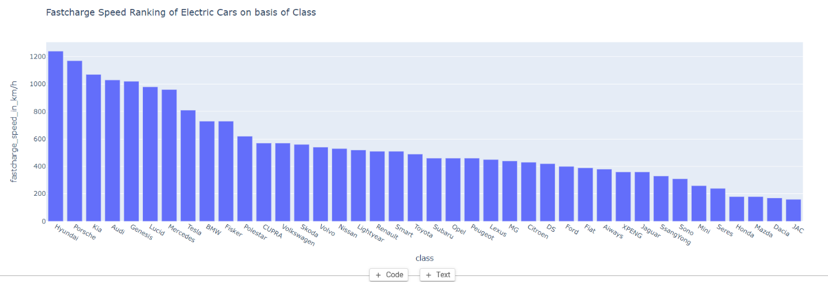

We can see that in Top 5 class in Acceleration ranking are :

1. Hyundai.

2. Porsche.

3. Kia.

4. Audi.

5. Genesis.

Total Number of Electric Vehicle Sales State Wise

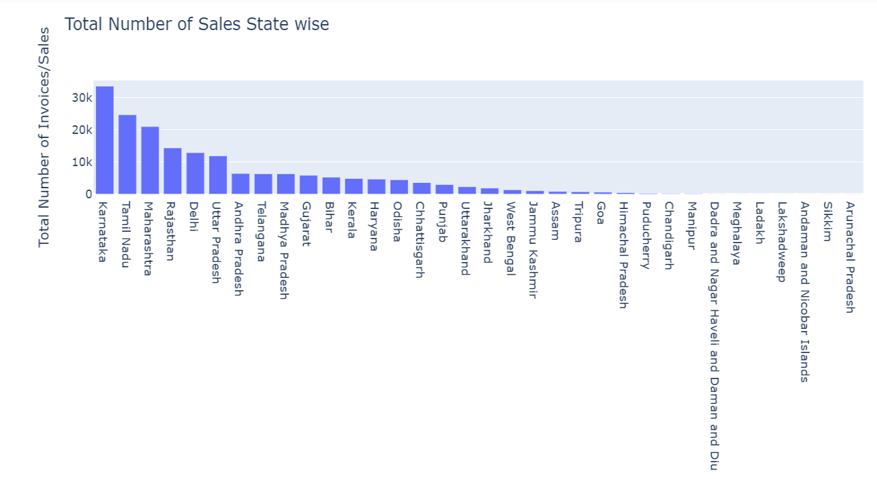

Top 5 State with highest number of Sales are:

1. Karnataka

2. Tamil Nadu

3. Maharashtra

4. Rajasthan

5. Delhi

Number of active vehicles:

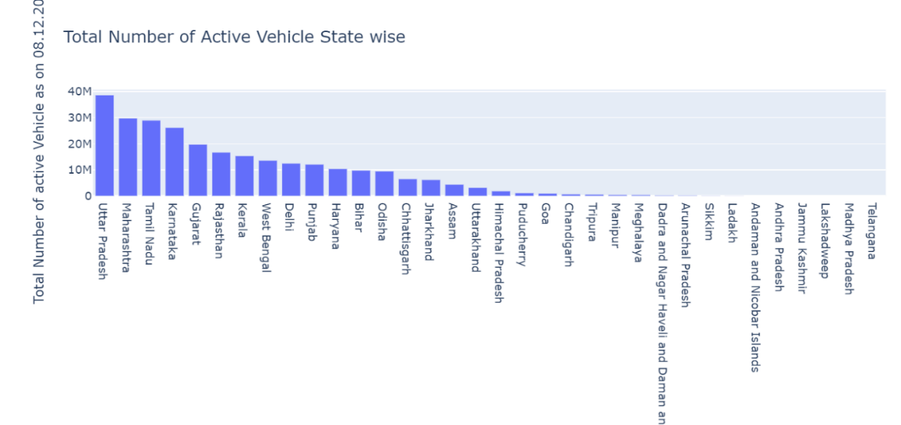

Top 5 State with highest number of active vehicles:

1.Uttar Pradesh

2. Maharashtra

3. Tamil Nadu

4. Karnataka

5. Gujarat

Number of active Electric Vehicle:

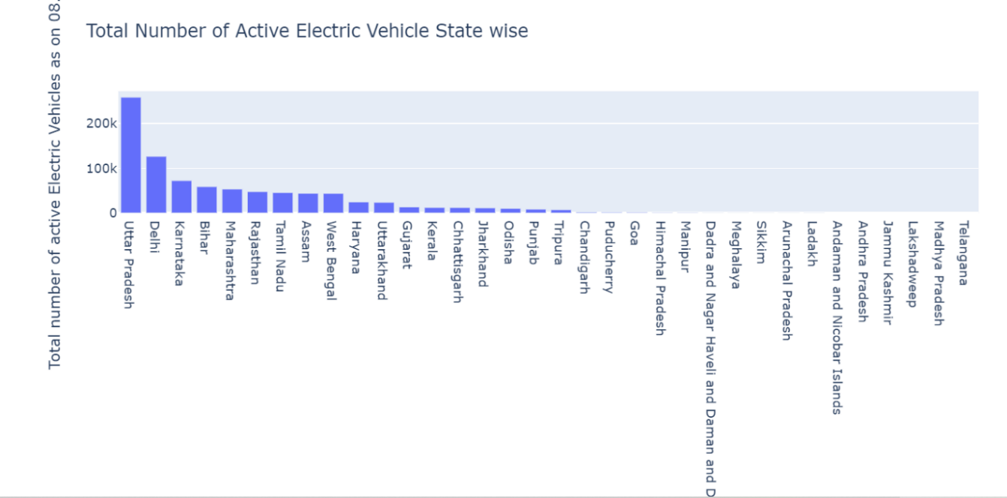

Top 5 State with highest number of active Electric Vehicle:

1. Uttar Pradesh

2. Delhi

3. Karnataka

4. Bihar

5. Maharashtra

Charging station Vs. State Wise

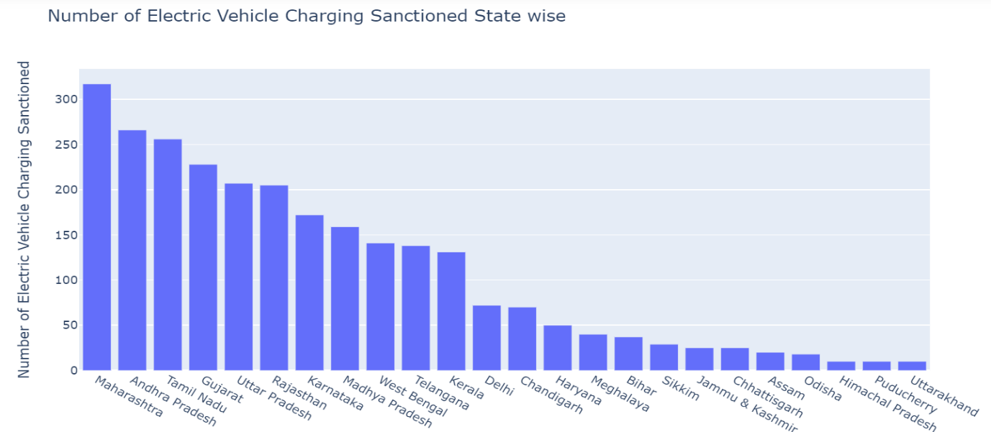

Top 5 states having higher number of charging station are:

1. Maharashtra

2. Andhra Pradesh

3. Tamil Nadu

4. Gujarat

5. Uttar Pradesh

Charging Stations Vs. Highways

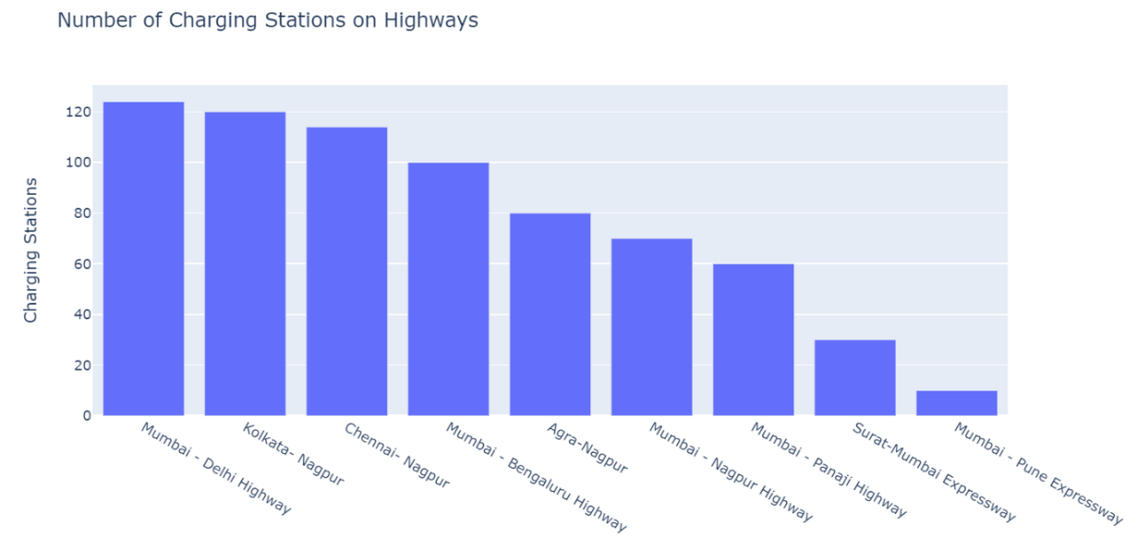

Top 5 Highways are:

1. Mumbai - Delhi Highway
2. Kolkata- Nagpur
3. Chennai- Nagpur
4. Mumbai - Bengaluru Highway
5. Agra-Nagpur

**Customizing the Market Mix**

As we analysed from above data we can focus on some segments in India for start-ups in ev market is shown below

Two-wheeler EV segment

The Domestic vehicle sales data, signifies that the two-wheeler segment, with more contribution towards total vehicle sales, is the major driver for increased sales in the Indian automobile sector. The factors which could explain the dominance of two-wheeler segment in India is provided

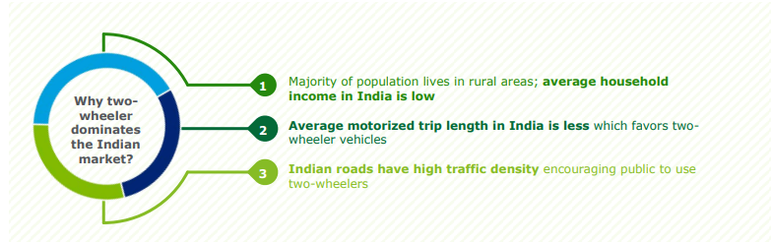

Several states have also come up with their EV policies which provide for fiscal and non-fiscal incentives over and above as provided by GoI.

Although the share of two-wheeler EVs is merely 17% of the overall EV population in the country, it is likely to follow the similar trend as it is observed in conventional vehicle market today.

**Three-wheeler EV segment**

Three-wheeler EV segment contributes to 79% of overall EV presence in India. Currently, this segment is driving the electrification of the Indian automobile industry. Such high population of 3W EVs could be described through following reasons

Three-wheelers are not only a mode of transportation but serve as the lifeline for several people formally / informally employed by their use.

3 W offers better value proposition in the shared mobility space. A ride as low as Rs.10 attracts passenger to take ride in E-Rickshaw

The cost of maintenance of 3W EV is almost reduced by 80 per cent compared to an ICE vehicle

**Four-wheeler EV segment**

The four-wheeler EV segment contributes to only 3% share of the country’s overall EV population. There are limited models available in EV 4W segment. However, major OEMs have planned to introduce more EV models suitable for Indian market in the future which could possibly increase competition in the market and boost their adoption.

Similar to the other EV vehicle segments, high prices are a major concern for large scale adoption of 4W EV. One of the key reasons for high EV prices is limited presence of ancillary manufacturers in India. Most of the auto-parts of these vehicles are imported, with China being the major supplier of EV components to India 19, which leads to the increase in prices of EVs. Hence, developing local manufacturing hubs for EV components could play a major role in bringing down the EV costs in the future and enable the sector to be resilient to supply disruption due to geo-political disturbances.

**E-buses**

Electric buses are the least adopted vehicle segment among EV, in India. However, with the growing focus of the GoI to transform the public transportation landscape in the country, several players have ventured into this arena and have started launching their electric bus models.

**Electric Vehicles @2030**

The Government of India has targeted 30% EV penetration by 2030. However, the momentum required to achieve the target would require transformational and radical measures to be adopted by Policy makers in this space.

**Overview**

An electric vehicle (EV) is propelled by an electric motor, powered by rechargeable battery packs. Below are the key components of an EV:

1. An electric motor
2. A power control unit
3. A rechargeable battery

The electric motor gets its power from a controller which in turn is powered by a rechargeable battery.

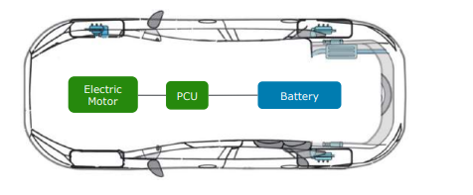

**Summary**

1. Based on geographical segment analysis we can see that Uttar Pradesh is highest in electric vehicle sales. Apart from Uttar Pradesh we have Maharashtra, Bihar, Karnataka, and Delhi having higher sale in electric vehicle.
2. The top 5 states having higher charging station are Maharashtra, Andhra Pradesh, Tamil Nadu, Gujarat, Uttar Pradesh.
3. Most commonly used class of electric vehicle is Compact SUV, Subcompact MPV and Premium Coupe.
4. Most commonly used models are Jaguar I-Pace, Hyundai Kona Electric, Tata Nexon EV Max, BYD E6, MG ZS EV
5. Based on Last segment which was electric vehicle in UK, Germany, Netherland we can see that based on efficiency, Battery, Range, Top speed, Fast charge Speed and acceleration common class of car which is purchased by consumers are Lucid, Tesla, BMW, Frisker, Kia, Mercedes Peugot and Citroen.
6. Also most common model used are eVito Tourer Extra-Long 90 kWh, e-tron Sportback 55 quattro, IX3, Ocean Ultra, Air Touring, Model Y Performance.

**Conclusion:**

Based upon the analysis we can conclude that Maharashtra, Gujarat, Andhra Pradesh, Tamil Nadu, Uttar Pradesh are the state where we can increase the market of Electric Vehicles. Also we can launch e-2 vehicle which are at high sales according to analysis. Also we can launch Jaguar I-Pace, Hyundai Kona Electric, Tata Nexon EV Max, BYD E6, MG ZS EV. Apart from this we can launch new model like eVito Tourer Extra-Long 90 kWh, e-tron Sportback 55 quattro, IX3,Ocean Ultra, Air Touring, Model Y Performance for increasing market profit.

**GitHub Link:**

<https://github.com/kd251995/Electric_Vehicle>